COMPILED LIST OF SOURCE CODE AND OUTPUT RESULT USED FOR VIDEO WATERMARKING IN MY PROJECT
- Playing and Reading of video Normally on Matlab
%% Read a video into MATLAB
videoFileReader = VideoReader('video 1.mp4');
depVideoPlayer = vision.DeployableVideoPlayer;
%Read frame by frame
while hasFrame(videoFileReader)
videoFrame = readFrame(videoFileReader);
%Display video
depVideoPlayer(videoFrame);
pause(1/videoFileReader.FrameRate);
end
Output File:
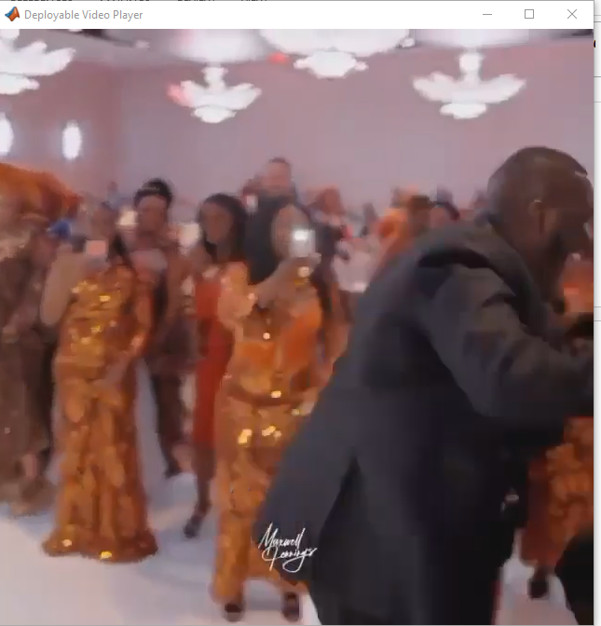

- The code for changing videos to sequence of Images in Matlab.
%%To read the video in matlab, we need to give it a name.
a= VideoReader('video 3.mp4');
get (a)
%% To start the reading of the video frame one by one and labelling it accordingly
a= VideoReader('video 3.mp4');
for img = 1:a.NumberOfFrames;
filename = strcat('frame',num2str(img),'.jpg');
b =read(a,img);
imwrite(b,filename);
end
Output Result: It print out all the whole code in the video, and list time from frame 1 – end ,, but due to space shortage ,I could not print all because it was long.
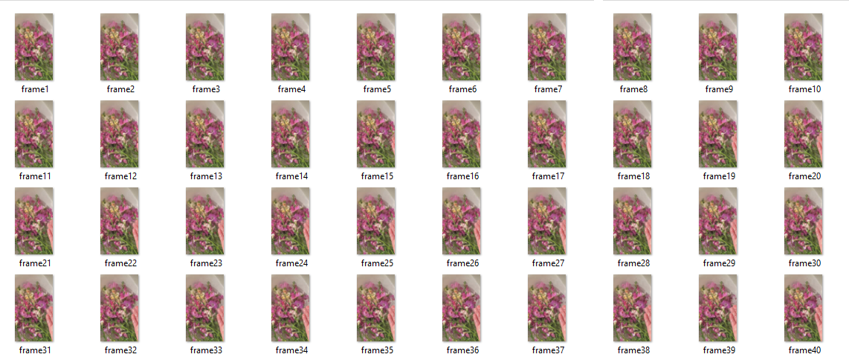

The Flowchart diagram using Matlab for video watermarking
Start

Import the video/Load the video

Extract video properties

Create loop for video file

Call each frame in the video file

Save each Frame and Repeat each process from 2-5

End

- Changing of Images in Video in single and sub heading plot in Matlab
%%Reading each frame one by one to the last one
VidObj = VideoReader('video 3.mp4');
%Num_Frames = Vptr.NumberOfFrames;
NFrames = round(VidObj.FrameRate*VidObj.Duration);
%Find the height and weight of the frame
Nrows = VidObj.height;
Ncols = VidObj.width;
%Preallocate the matrix
Img_s = zeros([Nrows,Ncols,NFrames]);
for i = 1:NFrames
%Read each frame
Img = readFrame(VidObj);
%To display all the frames
figure,imshow(Img);
end
%Save the matrix as .mat file
Save Video_Images.mat Img_s;
Note: The images are extracted into frame numbers from the video and they are sorted numerically.
Output Result:

- The changing of sequences of images in a folder into video in matlab
%Make the Below path as the Current Folder
cd('C:\Program Files\Matlab\bin\My Images watermark\videos folder.jpg');
%Obtain all the JPEG format files in the current folder
Files = dir('*.jpg');
%Find the total number of JPEG files in the Current Folder
NumFiles= size(Files,1);
%Preallocate a 4-D matrix to store the Image Sequence
%Matrix Format : [Height Width 3 Number_Of_Images]
Uphold_Images = uint8(zeros([294 419 3 NumFiles*2]));
%To write Video File
VideoObj = VideoWriter('React.mp4');
%Number of Frames per Second
VideoObj.FrameRate = 2;
%Define the Video Quality [ 0 to 100 ]
VideoObj.Quality = 60;
count=1;
for i = 1 : NumFiles
%Read the Images in the Current Folder one by one using For Loop
I = imread(Files(i).name);
%The Size of the Images are made same
ResizeImg = imresize(I,[294 419]);
%Each Image is copied 2 times so that in a second 1 image can be viewed
for j = 1 : 2
Uphold_Images(:,:,:,count)=ResizeImg;
count = count + 1;
end
end
%Open the File 'React.mp4'
open(VideoObj);
%Write the Images into the File 'React.mp4'
writeVideo(VideoObj,Uphold_Images );
%Close the file 'React.mp4'
close(VideoObj);
Output Result:

- How to watermark a video using logo images (Visible watermarking)
% Read in the video file
vidObj = VideoReader('video 2.mp4');

% Read in the watermark image
watermark = imread('table 2.jpg');
watermark_alpha = 0.5; % alpha value for watermark transparency (adjust as needed)

% Define the location of the watermark in the video frame
watermark_pos = [50, 50];

% Create a new video writer object
outObj = VideoWriter('marked.mp4', 'MPEG-4');
open(outObj);

% Loop over each frame in the video and add the watermark
while hasFrame(vidObj)
frame = readFrame(vidObj);

% Add the watermark to the frame
watermarked_frame = frame;
watermarked_frame(watermark_pos(1):watermark_pos(1)+size(watermark, 1)-1, ...
watermark_pos(2):watermark_pos(2)+size(watermark, 2)-1, :) = ...
(1-watermark_alpha)*watermarked_frame(watermark_pos(1):watermark_pos(1)+size(watermark, 1)-1, ...
watermark_pos(2):watermark_pos(2)+size(watermark, 2)-1, :) + ...
watermark_alpha*watermark;

% Write the watermarked frame to the new video
writeVideo(outObj, watermarked_frame);
end
once you paste the code in your editor,just wait a little, to find the output object, Then implay it,if it thows error relax and redo it or give it another name,it will give the watermarked video with logo.
implay('marked.mp4')
Output Result:

- File Insertion for Video watermarking
% Load the original MP4 video file
video = VideoReader('video 2.mp4');
% Determine the number of frames and frame dimensions
numFrames = video.NumberOfFrames;
frameHeight = video.Height;
frameWidth = video.Width;

% Create a new MP4 video file with the inserted file
outputFilename = 'Rested_day.mp4';
writerObj = VideoWriter(outputFilename, 'MPEG-4');
open(writerObj);

% Loop through each frame of the original video and write it to the new video
for k = 1:numFrames
% Read the current frame
frame = read(video, k);

% Insert the file into the frame (for example, a JPG image file)
if mod(k, 80) == 0 % insert the file every 80 frames
file = imread('table2.jpg');
file = imresize(file, [frameHeight/4, frameWidth/4]); % resize the file to fit a quarter of the frame
[fileHeight, fileWidth, ~] = size(file);
rowStart = randi(frameHeight - fileHeight);
colStart = randi(frameWidth - fileWidth);
frame(rowStart:rowStart+fileHeight-1, colStart:colStart+fileWidth-1, :) = file;
end

% Write the modified frame to the new video
writeVideo(writerObj, frame);
end

% Close the new video file
close(writerObj);
Output Result:

- The code for audio sound removal using Patchwork Techniques.
% Read the input video file
videoObj = VideoReader('video 1.mp4');
% Define the patch size and overlap between patches
patchSize = [100, 100];
overlapSize = [25, 25];
% Determine the number of rows and columns of patches
nRows = floor((videoObj.Height - overlapSize(1)) / (patchSize(1) - overlapSize(1)));
nCols = floor((videoObj.Width - overlapSize(2)) / (patchSize(2) - overlapSize(2)));
% Initialize the output video file
outputVideo = VideoWriter('court.avi');
open(outputVideo);

% Iterate through all frames of the video
while hasFrame(videoObj)
% Read the current frame
currentFrame = readFrame(videoObj);

% Initialize the output frame
outputFrame = zeros(videoObj.Height, videoObj.Width, 3, 'uint8');

% Iterate through all patches in the current frame
for iRow = 1:nRows
for iCol = 1:nCols
% Compute the coordinates of the current patch
patchTop = (iRow - 1) * (patchSize(1) - overlapSize(1)) + 1;
patchBottom = patchTop + patchSize(1) - 1;
patchLeft = (iCol - 1) * (patchSize(2) - overlapSize(2)) + 1;
patchRight = patchLeft + patchSize(2) - 1;

% Extract the current patch from the input frame
patch = currentFrame(patchTop:patchBottom, patchLeft:patchRight, :);

% Insert the current patch into the output frame
outputFrame(patchTop:patchBottom, patchLeft:patchRight, :) = patch;
end
end
% Write the output frame to the output video file
writeVideo(outputVideo, outputFrame);
end
implay(outputVideo)
% Close the output video file and release the input video object
close(outputVideo);
delete(videoObj);
Output Result:

- % Read the input video file
% Read the input video file
videoObj = VideoReader('video 1.mp4');

% Define the number of temporal layers
numLayers = 3;
% Define the stack decomposition filters
filters = cell(numLayers, 1);
for i = 1:numLayers
filters{i} = fspecial('gaussian', [i*2+1 i*2+1], i);
end
% Initialize the output video file
outputVideo = VideoWriter('mine.avi');
open(outputVideo);
% Iterate through all frames of the video
while hasFrame(videoObj)
% Read the current frame
currentFrame = readFrame(videoObj);
% Initialize the temporal layers
layers = cell(numLayers, 1);
for i = 1:numLayers
layers{i} = zeros(size(currentFrame));
end
% Apply the stack decomposition filters to the current frame
for i = 1:numLayers
filtered = imfilter(currentFrame, filters{i}, 'replicate', 'same', 'conv');
layers{i} = currentFrame - filtered;
end
% Write the temporal layers to the output video file
for i = 1:numLayers
writeVideo(outputVideo, layers{i});
end
end
disp(outputVideo)
% Close the output video file and release the input video object
close(outputVideo);
delete(videoObj);
Output Result:

Attacks in videos of mp4 using Gaussian, Denoising, Geometric and compression in Matlab

- %%% Adding Gaussian noise to a mp4 video in matlab

%% Load the input MP4 video
v = VideoReader('video 1.mp4');

% Create a VideoWriter object for the output video
vw = VideoWriter('output.mp4', 'MPEG-4');
vw.FrameRate = v.FrameRate;

% Open the VideoWriter object
open(vw);

% Loop through each frame of the video and apply a Gaussian noise distortion
while hasFrame(v)
% Read the current frame
frame = readFrame(v);

% Apply Gaussian noise distortion to the frame
% For example, add noise with mean 0 and standard deviation 10
noisyFrame = imnoise(frame, 'gaussian', 0, 10^0.001);

% Write the modified frame to the output video
writeVideo(vw, noisyFrame);
end

% Close the VideoWriter object
close(vw);

imshow(noisyFrame)

Output Result:
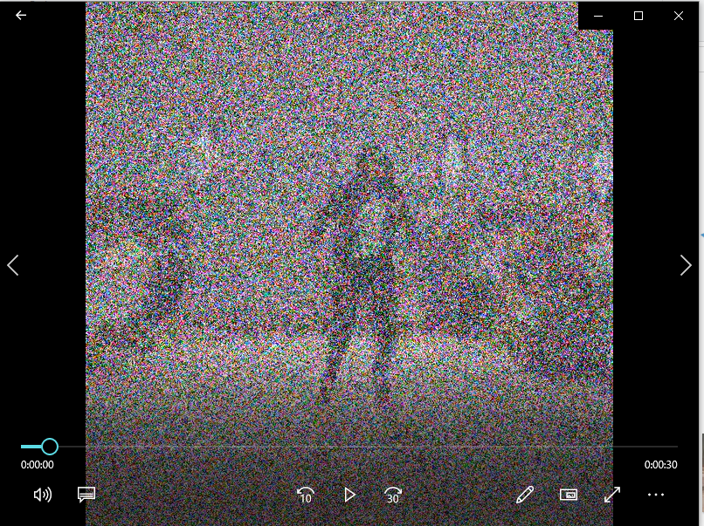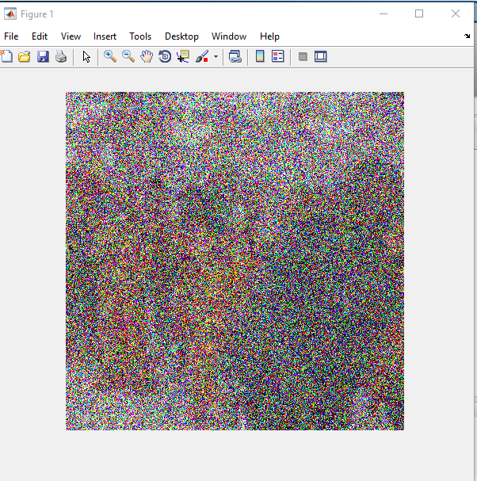

Left: The mp4 video of noisy images Right: Last Frame of the Video in image format

2. %% Matlab Code showing denoise frame attack in mp4 video file

% Load the input MP4 video
v = VideoReader('video 1.mp4');

% Create a VideoWriter object for the output video
vw = VideoWriter('output.mp4', 'MPEG-4');
vw.FrameRate = v.FrameRate;

% Open the VideoWriter object
open(vw);

% Loop through each frame of the video and apply a Gaussian denoising attack
while hasFrame(v)
% Read the current frame
frame = readFrame(v);

% Apply Gaussian denoising to the frame
% For example, remove noise with standard deviation 10
denoisedFrame = imgaussfilt(frame, 10);

% Write the modified frame to the output video
writeVideo(vw, denoisedFrame);
end

% Close the VideoWriter object
close(vw);
imshow(denoisedFrame)

Output Result:

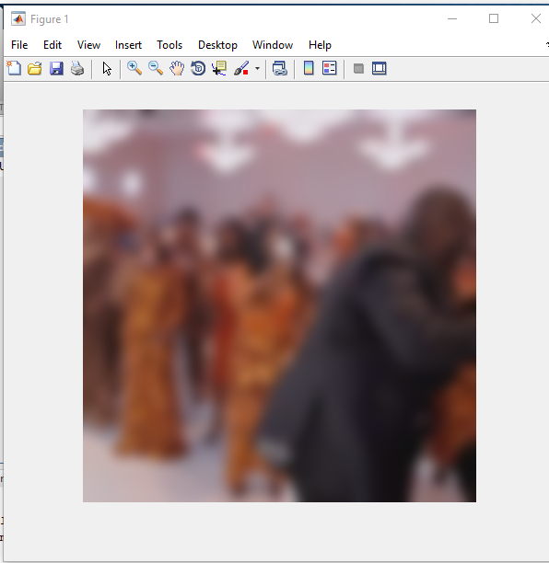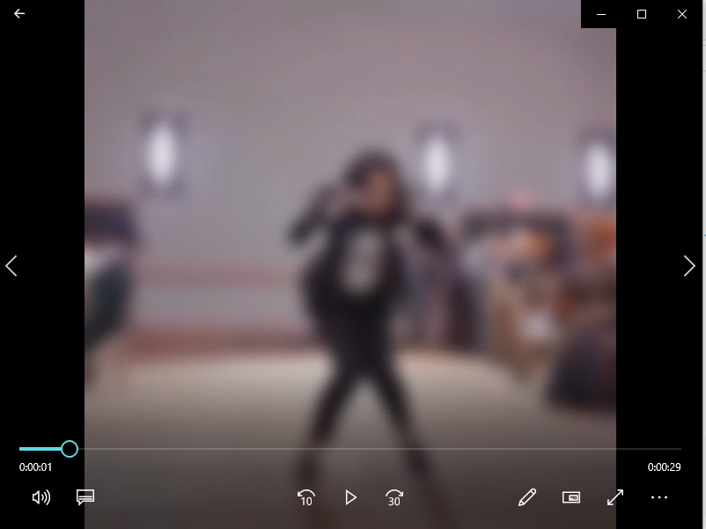

Left: Last Frame of the Video in image format Right: The mp4 video of denoise in images

- %%%Quantization attack in mp4 video using matlab

% Load the input MP4 video
v = VideoReader('video 1.mp4');

% Create a VideoWriter object for the output video
vw = VideoWriter('output.mp4', 'MPEG-4');
vw.FrameRate = v.FrameRate;

% Open the VideoWriter object
open(vw);

% Loop through each frame of the video and apply a color quantization attack
while hasFrame(v)
% Read the current frame
frame = readFrame(v);

% Apply color quantization to the frame
% For example, reduce the color depth to 4 bits
quantizedFrame = imquantize(frame, linspace(0, 1, 2^4));

% Convert the quantized frame to uint8 format for saving to MP4
quantizedFrame = uint8(quantizedFrame * (256 / 2^4 - 1));

% Write the modified frame to the output video
writeVideo(vw, quantizedFrame);
end

% Close the VideoWriter object
close(vw);
imshow(quantizedFrame)

Output Result:

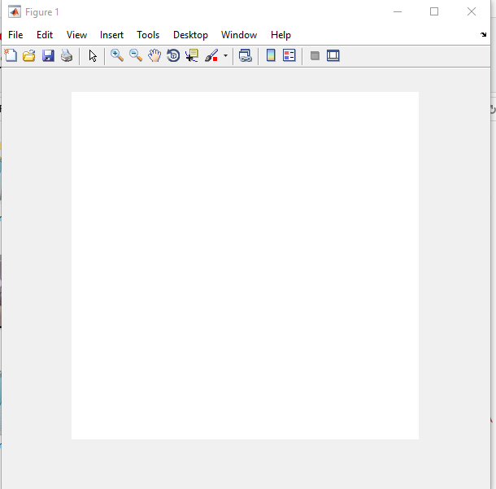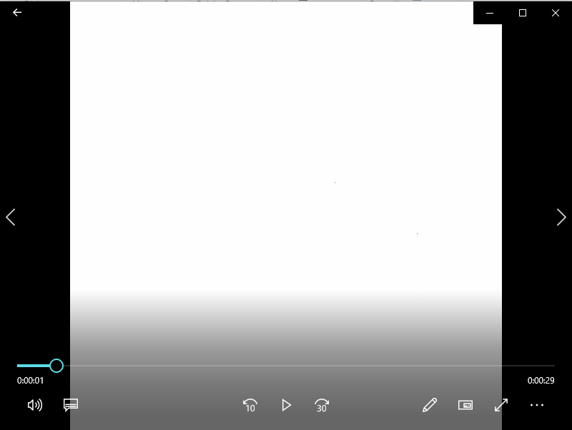

Left: Last Frame of the Video in image format Right: The mp4 video of Quantized frame in images

- %% Compressed Frame in mp4 video in matlab

% Load the input MP4 video
v = VideoReader('video 1.mp4');

% Create a VideoWriter object for the output video
vw = VideoWriter('output.mp4', 'MPEG-4');
vw.FrameRate = v.FrameRate;

% Open the VideoWriter object
open(vw);

% Set the target resolution for the output video
targetWidth = 640;
targetHeight = 360;

% Loop through each frame of the video and apply a compression attack
while hasFrame(v)
% Read the current frame
frame = readFrame(v);

% Resize the frame to the target resolution
resizedFrame = imresize(frame, [targetHeight, targetWidth]);

% Apply lossy compression to the resized frame
% For example, compress the frame with a quality factor of 50
compressedFrame = imresize(imresize(resizedFrame, 0.5), 2, 'nearest');

% Write the modified frame to the output video
writeVideo(vw, compressedFrame);
end

% Close the VideoWriter object
close(vw);
imshow(compressedFrame)

Output Result:

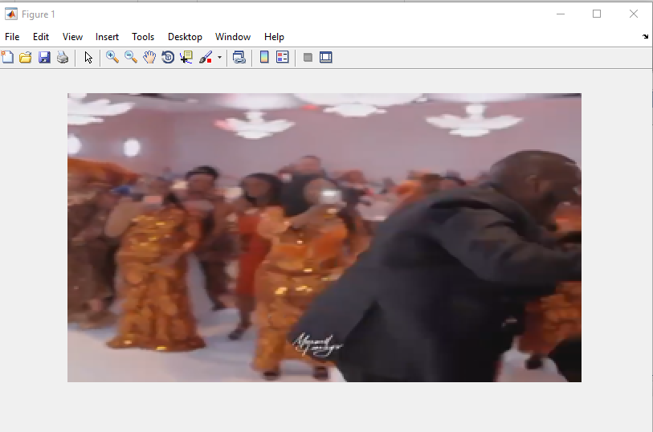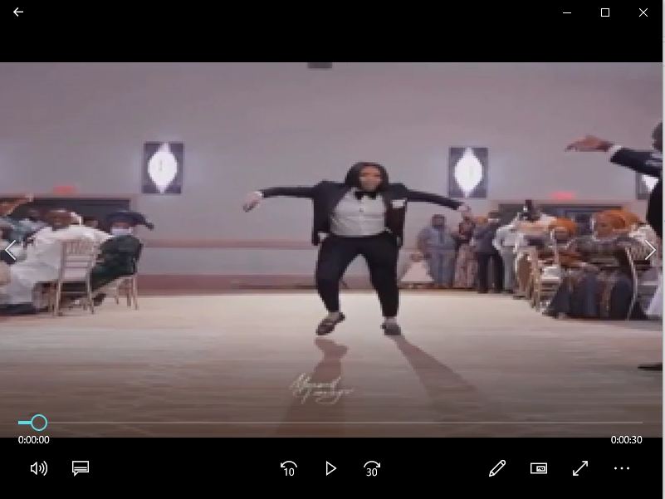

Left: Last Frame of the Video in image format Right: The mp4 video of Compressed frame in images

- %%%Geometric attack Frame in mp4 video in matlab

% Load the input MP4 video
v = VideoReader('video 1.mp4');

% Create a VideoWriter object for the output video
vw = VideoWriter('output.mp4', 'MPEG-4');
vw.FrameRate = v.FrameRate;

% Open the VideoWriter object
open(vw);

% Loop through each frame of the video and apply a geometric attack
while hasFrame(v)
% Read the current frame
frame = readFrame(v);

% Apply a geometric attack to the frame
% For example, scale the frame by a factor of 1.5
scaledFrame = imresize(frame, 1.5);

% Write the modified frame to the output video
writeVideo(vw, scaledFrame);
end

% Close the VideoWriter object
close(vw);
imshow(scaledFrame)

Output Result:

Left: Last Frame of the Video in image format Right: The mp4 video of Scaled frame in images

